**KiwiSAT-TEC Help File.**

**Introduction: KiwiSAT-TEC** is a Windows program that reads the text files created by the KiwiSAT-rtl program. These text files represent 8 bit I/Q files generated by the rtl-sdr Dongles. This program calculates the Phase Difference (Dif Phase) between the 437.425 MHz and 145.865 MHz beacon signals and hence calculates the Total Electron Content (TEC) of the ionospheric path between the observer and the satellite.

**Theory:**   In the rtl dongle documentation, it mentions that the RTL chip produces 8 bit data for the I and Q files.  
The KiwiSAT-rtl program produces text files that are these 8 bit data samples translated to decimal values.

The range of 8 bit data values must be from decimal 0 to 255.  
If we assume 00 is the minimum then we can make that the maximum negative value of I or Q and 255 is the maximum value of I or Q.  
To derive the values for I and Q, the program will subtract 128 from each reading to account for the negative values.   
The amplitude of the sample is square root (sqrt) of I squared + Q squared (Pythagoras).

The phase of the sample is the angle whose tangent (arctan) is Q/I. The result is in radians.

Now according to the TEC papers the 437 signals will have a larger phase than the 145 signal.  
The differential phase is then the 437 phase - 145 phase.  
Going back to TEC paper Chapter05 equation 4 (reference 1) and putting in the numbers for KiwiSATwe get: Diff phase/6.614 = TEC.

If we now repeat this for all 60 samples in the I/Q text files (5 minute run at 5 second intervals), the program will generate a set of text files for I, Q, Amplitude, Phase, Differential Phase and TEC for each sample.

**Installation:** Download the KiwiSAT-TEC.exe file from:

<https://www.dropbox.com/s/a5dp066imvqxswz/KiwiSAT_TEC.exe?dl=0>

Copy this file to C:\KiwiSAT\TEC.

Download the User.txt file from: <https://www.dropbox.com/s/qlsi50ndon3wabo/User.txt?dl=0>

And copy this file to C:\KiwiSAT\TEC.

**Usage:** Run KiwiSAT_exe.

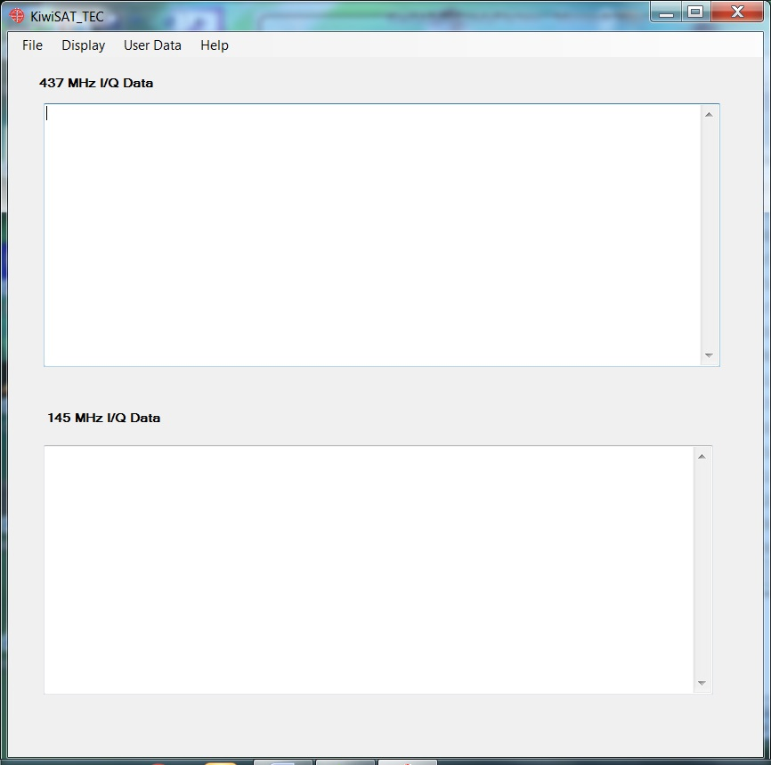

Click on the “User Data” and edit the User ID, Location, Latitude and longitude to suit. Save the new details and exit.

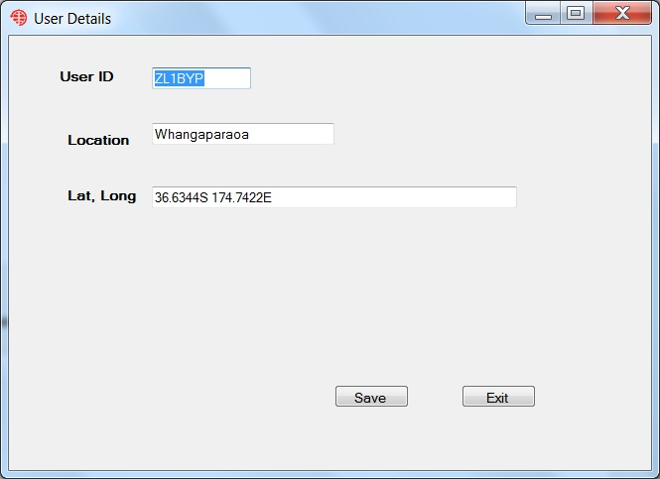

Select “File” – “Open 437 I/Q” and navigate to a 437_IQ.txt file generated by KiwiSAT-rtl.

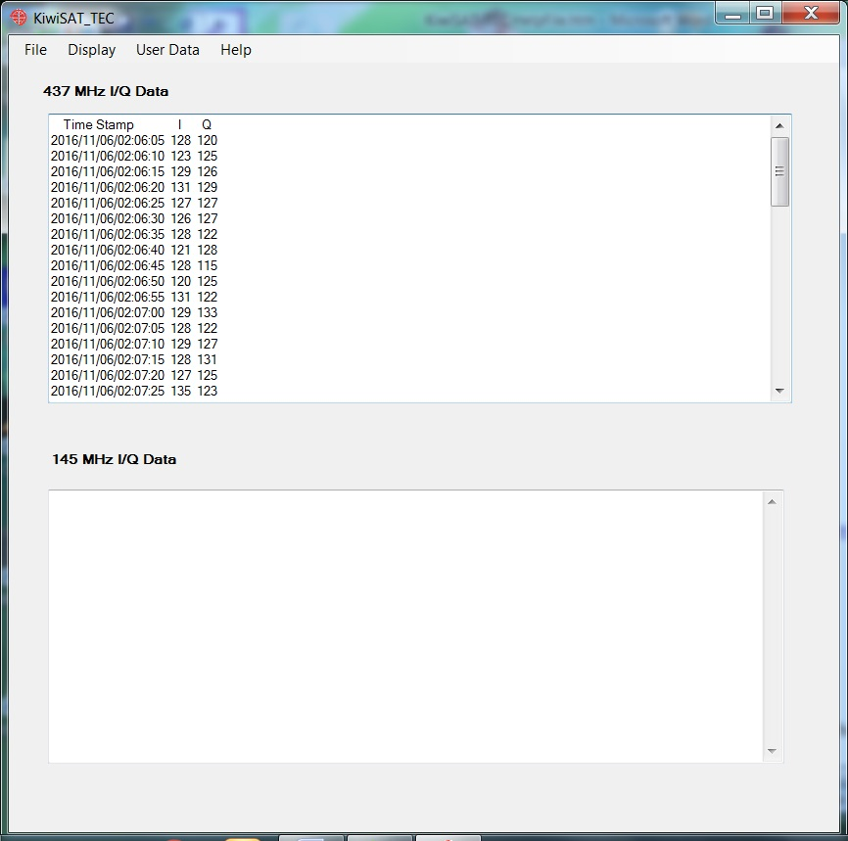

Now select “File” – “Open 145 I/Q” and navigate to a 145_IQ.txt file generated by KiwiSAT-rtl.

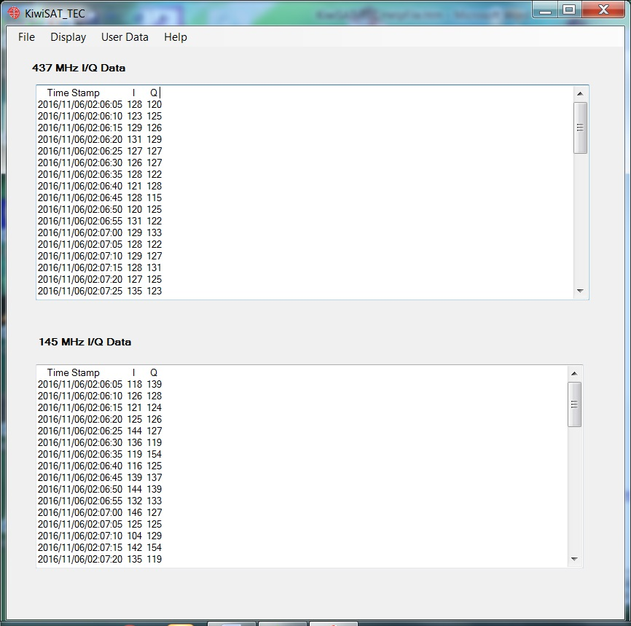

Now select the “Display” tab and then one of the options to display 437 Amplitude and Phase, 145 Amplitude and Phase or Differential Phase and TEC. The Differential Phase and TEC data can be saved to a text file for uploading to a future server.

The “Help” tab gives an about screen and access to this help file.

**Further Work:** Some data files for the actual beacons are required to confirm that KiwiSAT_TEC is working correctly.

The program can be used to generate test files and for demonstrations. More testing is required to confirm that this software is suitable for measurements after launch.

Reference 1: <ftp://ftp.ngdc.noaa.gov/STP/SOLAR_DATA/Publications/Miscellaneous-STP/World_Ionosphere_Thermosphere_Study/Chapter05.pdf>

References for I/Q data: <http://whiteboard.ping.se/SDR/IQ> and http://www.ni.com/tutorial/4805/en/

Terry Osborne ZL2BAC

11/11/2016